

**2015S2-DM2124-PRODUCTION AND PROJECT MANAGEMENT**

**Assignment 02**

**Done By:** Sri Sham Haran S/O R. Raja (155129R)

**Lecturer/Tutor-In-charge:**

Mr. Chris Hong

Mr. Quah Poh Yong

**Assignment 2 (part 1): Project Management Plan**

THIS IS POINT FORM DRAFT. PLEASE ELABORATE APPROPRIATELY

Admission No: 155129R

Name: Sri Sham Haran S/O R Raja

# Project Overview

## Title

* *The title of the project <<<*

Agent vs. Agent

## Overview of the project

* *What is your project? Explain and describe the project. <<<*
* *What do you want to achieve? <<<*
* *Who is your target audience? <<<*
* *Which platform are you developing for? <<<*
* *Are there any specific points with your project?*
  + Develop Agent vs. Agent to be released for iOS and Android devices. Agent vs. Agent is a 3D real time multiplayer game, bomb game. Players play as agents trying to bomb each other and try to win. Bombing safes will allow the player to gain a power-up that will aid them in the game.
  + Agent vs. Agent to be developed, tested and published within 8 months
  + Top 200 in US Charts on Google Playstore and iOS App Store.
  + Target to (10 -18 Year Olds)
  + Achieve a unique game whilst innovating from existing concepts. Provide a different gaming experience to target audience.

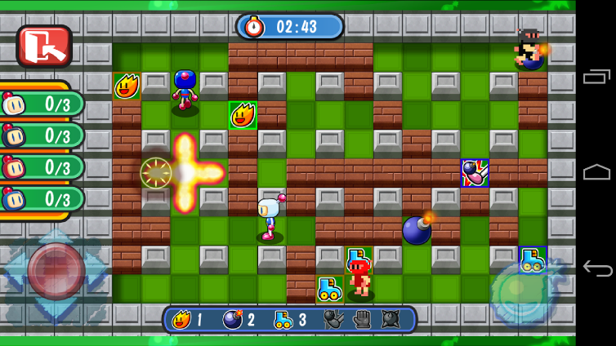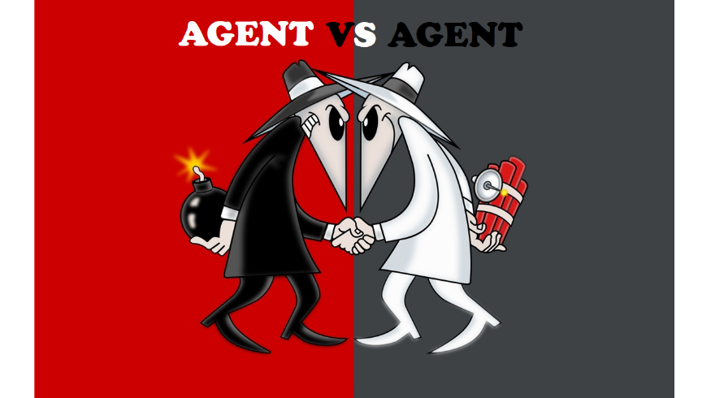

# Team

## Team structure <<CFM with CH

* *How are you going to build a team?*
* *What will be your team structure*

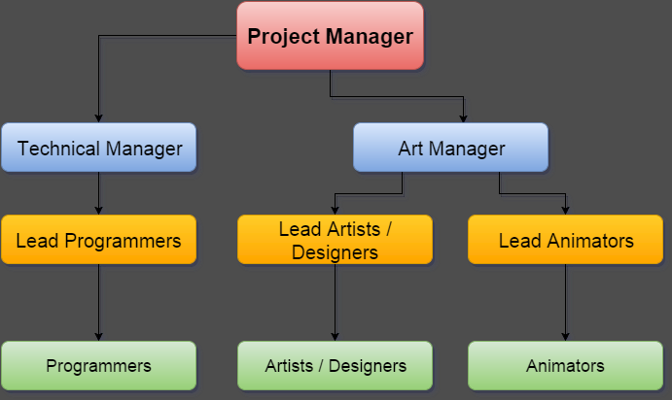

|  |  |
| --- | --- |
| **Role** | **Quantity** |
| Project Manager | 1 |
| Technical Manager | 1 |
| Art Manager | 1 |
| Lead Programmers | 1 |
| Lead Artists/Designers | 1 |
| Lead Animators | 1 |
| Programmers | 2 |
| Artists / Designers | 1 |
| Animators | 1 |

Elaborate on roles. Desc.

## Team efficiency

* *The plan for build up the efficient team*
* *How can you keep your team in stable?*
* *What will be the challenge and risk for the team management? <<cfm with CH*

The efficiency of the team will be maintained by encouraging the team to practice the following:

* + Effective Communication
  + Maintain a good understanding of the roles & responsibilities as well as the goal and objectives of the project.
  + Optimism and Commitment
  + Refrain from conflict or tension
  + Mutual Respect
  + Understanding the authority of each coworker

Challenges and risks:

* + Hard to relay change of scope(if any) to entire team
  + Possible deprivation of resources
  + Absence or lack of a properly detailed contingency plan

# System Preparation

* *What kind of system do you need for your development process?*
* *Is there any maintenance issue?<<cfm with CH*
  + Game Engine : Unity5
  + Modeling Software: Autodesk software(Maya, SoftImage, Motionbuilder)
  + Issue & Project Tracking : JIRA Software
  + Collaboration Programs: GitHub & SmartGit
  + Others: Photoshop, Illustrator, Visual Studio

Possible Issues:

* + JIRA boards and may not be updated consistently
  + File collaborations are likely to face many conflicts that may require manual resolution

# Agile Management Plan

* *The structure of your agile team << cfm with CH.*
* *Agile management Plan*
  + *The length of the each iteration*
  + *How to manage scrum daily meeting, review and preview meeting. <<cfm with CH what is preview meeting*

Agile Management Plan:

Each iteration span will be 2 weeks long.

Scrum daily meetings will occur where teams should establish what has been done and what needs to be done as well as clarify doubts and issues.

Scrum Review will occur nearing the end of each iteration where the team will review the sprint and change the project objectives such that it adapts to any issues that surface.

Scrum retrospective meeting occurs at the end of each iteration where the team looks and what has been done and what needs to be done as well as change objectives or general team attitude.

# Remarks

* *This part is optional for the assignment. If you want to make more note and details you can add any remarks here.*